String in Groovy
A string is a sequence of characters. Generally, a string is a data type and implemented as an array of bytes which stores sequence of characters. In Groovy, String class is available in java.lang.String objects as well as in groovy.lang. GString which is called interpolated strings in some programming language.

Note: In groovy, all the strings can be concatenated by using the + operator

Single-quoted string
In groovy, Single-quoted strings is a sequence of characters which is enclosed under single quotes.

Syntax:
- '________String________'

Example 1:
- package com.app
- class GroovyStringExample1 {
- static void main(args)
- {
- String s1 = 'Javatpoint'
- println s1
- println 'This is tutorial on Groovy at ' + s1
- }
- }
Output:
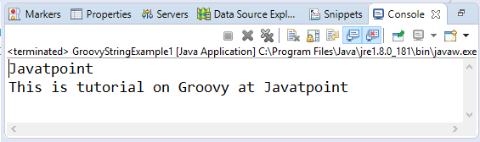

Double-quoted string
In groovy, Double-quoted string is a sequence of characters which is enclosed under double quotes.

Syntax:
- "________String________"

Example 2:
- package com.app
- class GroovyStringExample2 {
- static void main(args)
- {
- String s1 = "Javatpoint"
- println s1
- println "This is tutorial on Groovy at " + s1
- }
- }
Output:
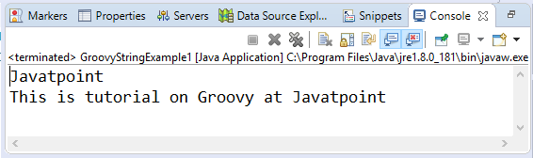
In Groovy, we can also use ${Variable _name} and $Variable_name instead of using the '+' operator. Using $Variable_name is known as interpolation. It can be used only when the string is defined inside the double quotes.

Example 3:
- package com.app
- class GroovyStringExample3 {
- static void main(args)
- {
- String s1 = "Javatpoint"
- println "This is tutorial on Groovy at ${s1} "
- println "This is tutorial on Groovy at $s1 "
- }
- }
Output:
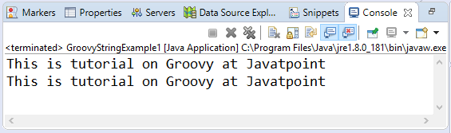

Triple-single-quoted string
In groovy, Triple-single-quoted string is a sequence of characters which is enclosed under triple single quotes.

Syntax:
- '''________String________'''

Example 4:
- package com.app
- class GroovyStringExample4 {
- static void main(args)
- {
- String s1 = '''This is groovy tutorial and we are learning string'''
- println s1
- }
- }
Output:
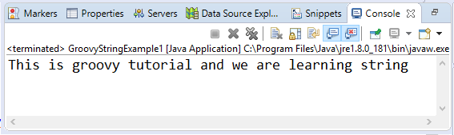
In Groovy, Triple-single-quoted strings are mostly used for multiple lines in a single variable.

Example 5:
- package com.app
- class GroovyStringExample5 {
- static void main(args)
- {
- String s1 = '''This is line 1
- This is line 2
- This is line 3
- This is line 4
- This is line 5'''
- println s1
- }}
Output:
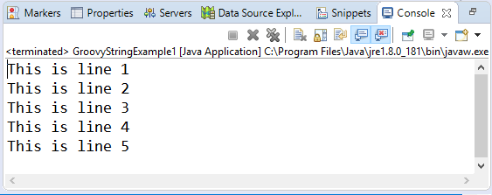

Triple-double-quoted string
In groovy, Triple-double-quoted string is a sequence of characters which is enclosed under triple double quotes.

Syntax:
- """________String________"""

Example 6:
- package com.app
- class GroovyStringExample6 {
- static void main(args)
- {
- String s1 = """This is groovy tutorial and we are learning string"""
- println s1
- }
- }
Output:
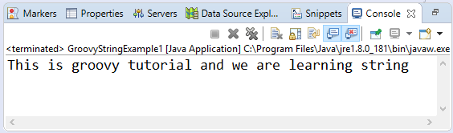
In Groovy, Triple-double-quoted strings are also used for multiple lines in a single variable.

Example 7:
- package com.app
- class GroovyStringExample7 {
- static void main(args)
- {
- String s1 = """This is line 1
- This is line 2
- This is line 3
- This is line 4
- This is line 5"""
- println s1
- }
- }
Output:
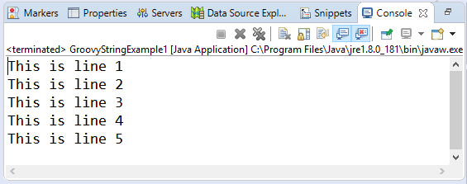
In Triple-double-quoted strings, we can also use ${Variable _name} and $Variable_name instead of using the '+' operator. Using $Variable_name is known as interpolation.

Example 8:
- package com.app
- class GroovyStringExample8 {
- static void main(args)
- {
- String s1 = """This is line 1
- This is line 2
- This is line 3
- This is line 4
- This is line 5"""
- println """Hello $s1"""
- println """Hey $s1"""
- }
- }
Output:
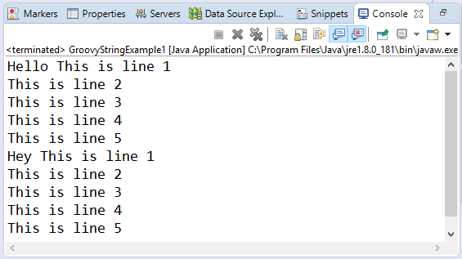

Slashy string
In groovy, slashy string is a sequence of characters which is enclosed in / forward slash. Slashy strings are useful for defining regular expressions and patterns where there is no need to escape backslashes.

Syntax:
- /________String________/

Example 9:
- package com.app
- class GroovyStringExample9 {
- static void main(args)
- {
- String s1 = /This is groovy tutorial and we are learning string/
- println s1
- }
- }
Output:
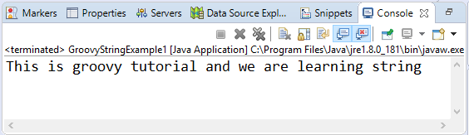
In Groovy, slashy strings are also used for multiple lines in a single variable.

Example 10:
- package com.app
- class GroovyStringExample11 {
- static void main(args)
- {
- String s1 = /This is line 1
- This is line 2
- This is line 3
- This is line 4
- This is line 5/
- println s1
- }}
Output:
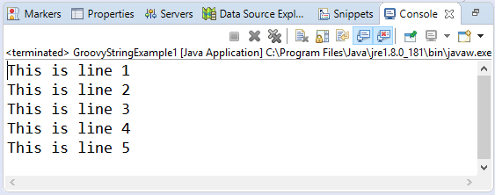
In slashy strings we can also use ${Variable _name} and $Variable_name instead of using the '+' operator. Using $Variable_name is known as interpolation.

Example 11:
- package com.app
- class GroovyStringExample11 {
- static void main(args)
- {
- String s1 = /This is line 1
- This is line 2
- This is line 3
- This is line 4
- This is line 5/
- println """Hello ${s1}"""
- println """Hey $s1"""
- }}
Output:
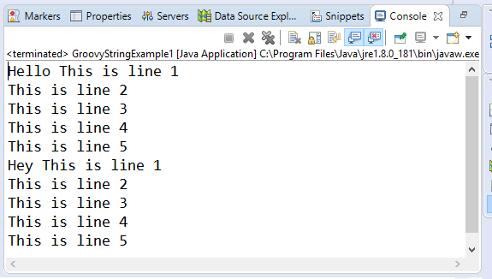

Dollar slashy string
In groovy, dollar slashy string is a sequence of characters which is enclosed in the $/ dollar and a forward slash. Dollar slashy strings are useful for defining regular expressions and patterns where there is no need to escape backslashes.

Syntax:
- $/________String________/$

Example 12:
- package com.app
- class GroovyStringExample9 {
- static void main(args)
- {
- String s1 = $/This is groovy tutorial and we are learning string /$
- println s1
- }
- }
Output:
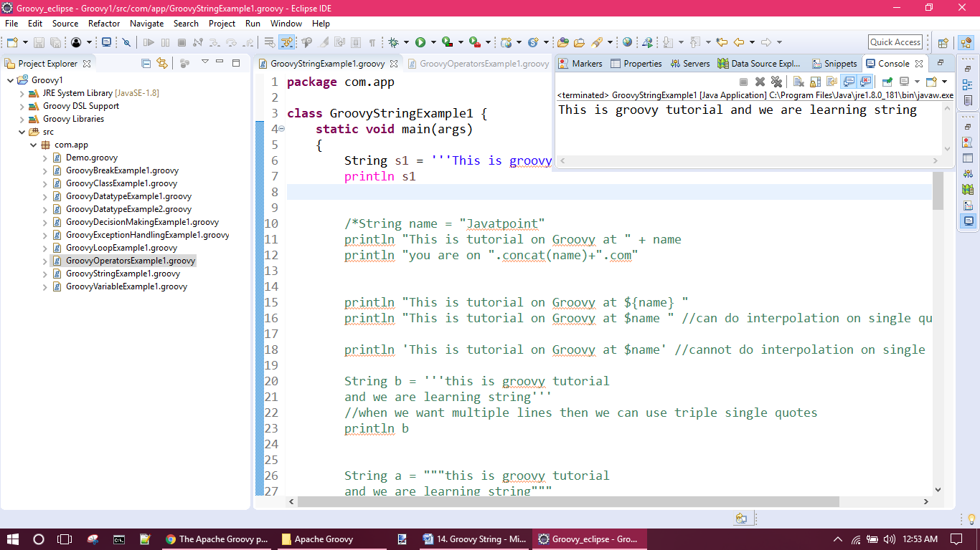
In Groovy, dollar slashy strings are also used for multiple lines in a single variable.

Example 13:
- package com.app
- class GroovyStringExample13 {
- static void main(args)
- {
- String s1 = $/This is line 1
- This is line 2
- This is line 3
- This is line 4
- This is line 5/$
- println s1
- }
- }
Output:

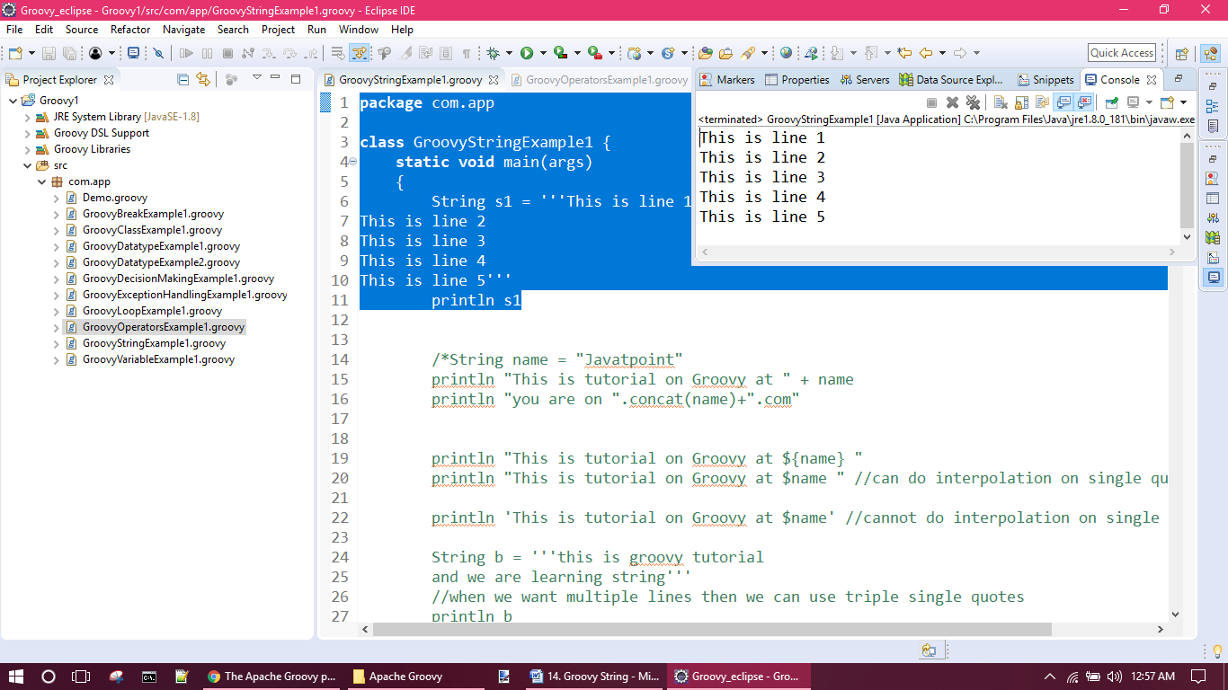
In dollar slashy strings, we can also use ${Variable _name} and $Variable_name instead of using the '+' operator. Using $Variable_name is known as interpolation.

Example 11:
- package com.app
- class GroovyStringExample11 {
- static void main(args)
- {
- String s1 = $/This is line 1
- This is line 2
- This is line 3
- This is line 4
- This is line 5/$
- println """Hello ${s1}"""
- println """Hey $s1"""
- }}
Output:
